**CMPT 376 Project 2 Draft**

Zhixin Huang

301326521

1. Written documentation

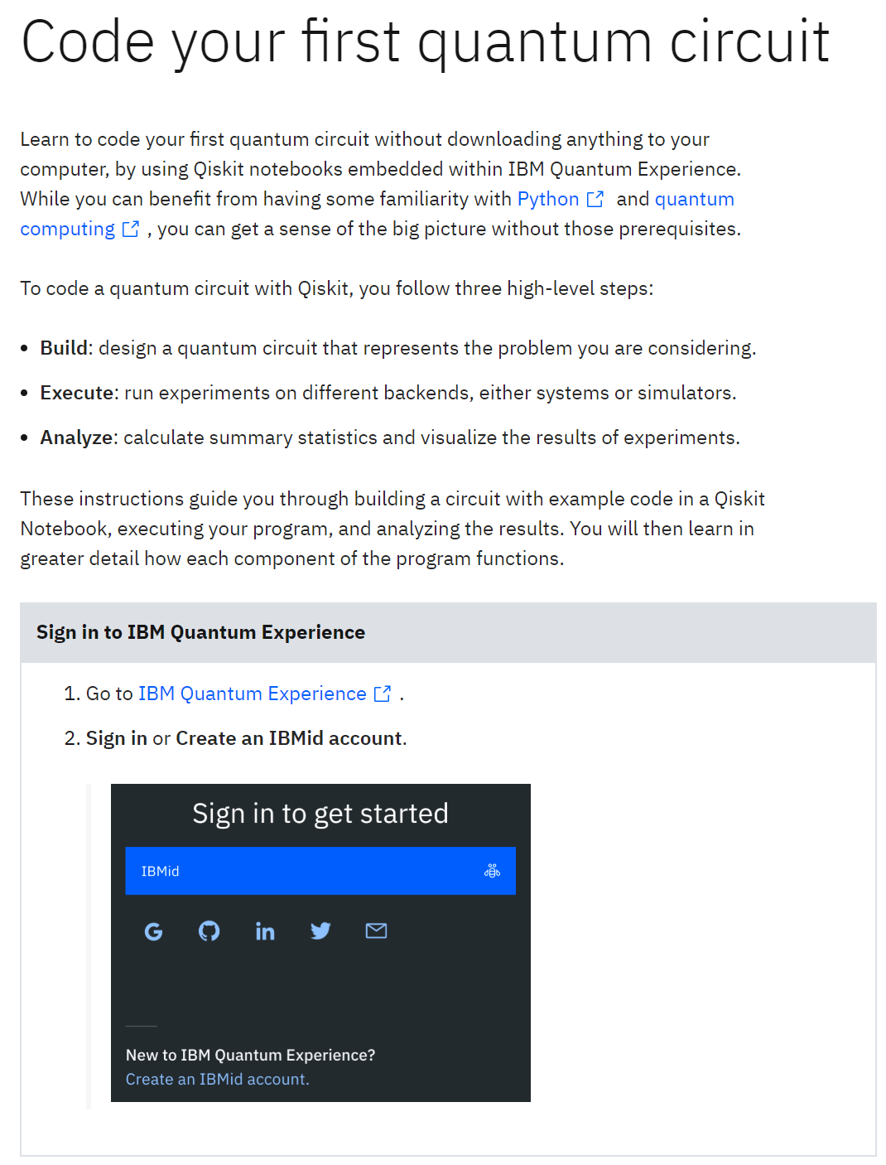

1. Code documentation

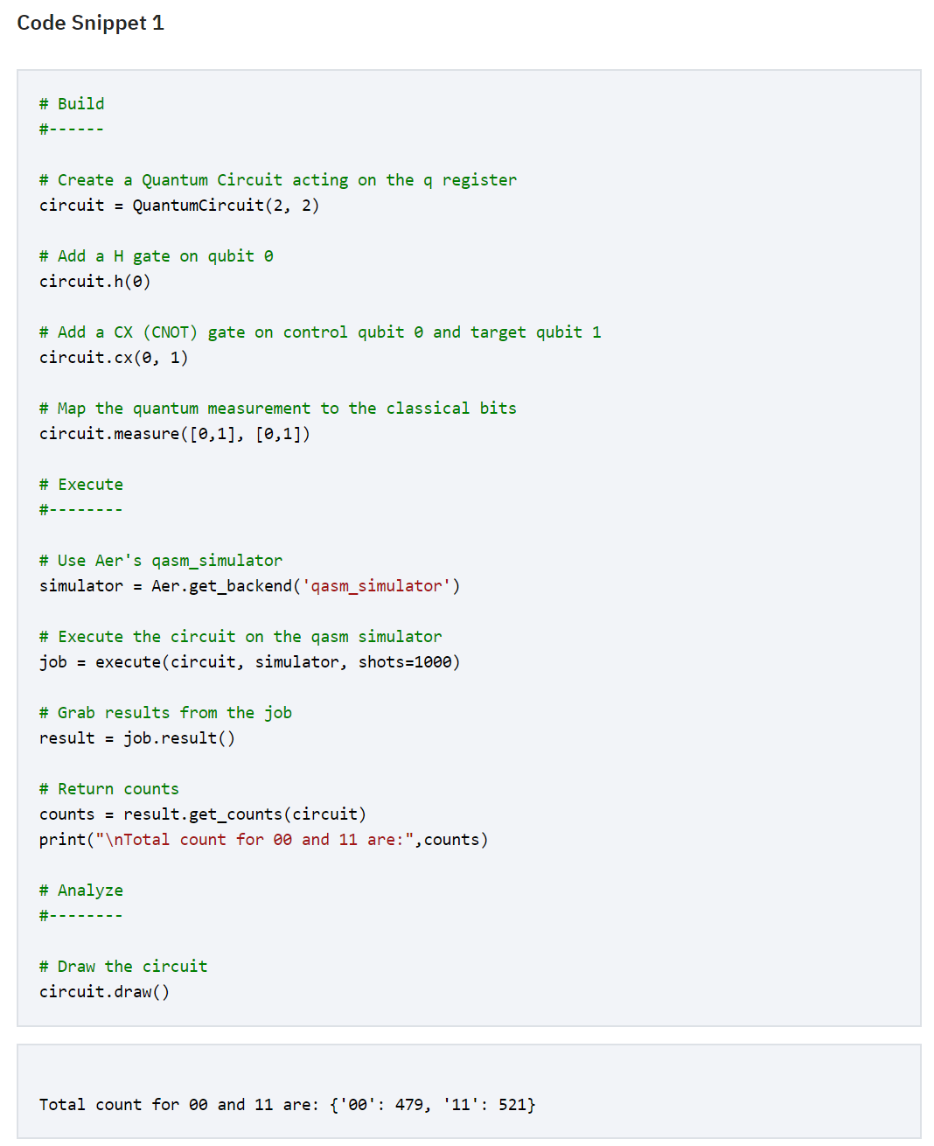

1. Community documentation

